***PUBLIC NOTICE***
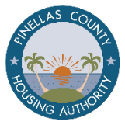

The Pinellas County Housing Authority (PCHA) is pleased to announce the opening of the Project-Based Voucher (PBV) waiting list for Lakeside Terrace Apartments, located at 4200 62nd Avenue, Pinellas Park, Florida 33781.
Who can apply to the Lakeside Terrace PBV Wait List? Anyone can apply. However, to be eligible for assistance, at least one household member must have legal residency status in the United States. Legal residency will be verified at the time you are selected from the waiting list.
Who is eligible for the Lakeside Terrace PBV Program? Eligibility for the PBV program is determined by the U.S. Department of Housing and Urban Development (HUD) and includes: Income limits, Legal Residency or Citizenship, Criminal Background Screening, & Other HUD Requirements. These eligibility requirements are not part of the pre-application.

Applications will only be accepted for families who meet the 1-bedroom eligibility guidelines as listed below.

1-BEDROOM ELIGIBILITY: 1 – 2 PERSONS

Income Limits: Household income must not exceed 50% of the current Area Median Income (AMI), based on household size:

$40,150– One Person $45,850– Two Persons

Pre-applications will ONLY be available electronically, via the online application portal at: https://portals.pinellashousing.com/
on the dates listed below:

📅 APPLICATION PERIOD:
Opens: Monday, July 13, 2026, at 8:00 AM EST
Closes: Friday, July 17, 2026, at 11:59 PM EST
Applicants may apply online anytime of the day or night during the waiting list opening times.
Completed pre-applications will be randomly selected to be added to the waiting list.

Applicants may complete the online pre-application using a personal computer, smartphone, tablet, or any public computer with internet access. Online pre-applications are available in English and Spanish.
💡 Need help? Free In-Person Assistance:
📍 PCHA Office – 11479 Ulmerton Rd, Largo, Florida 33773
🕘 July 13 & July 15, 2026 | ⏰ 9:00 AM – 12:00 PM EST
Reasonable Accommodation:
Applicants with disabilities may request a reasonable accommodation to complete the pre-application process. If an applicant is unable to complete the online pre-application because of a disability, a paper pre-application may be requested by calling (727) 443-7684 during the following hours: Monday, July 13, 2026, through Thursday, July 16, 2026: 8:00 AM – 5:00 PM EST and Friday, July 17, 2026: 8:00 AM – 12:00 PM (Noon) EST. Paper pre-applications may also be picked up in-person at the Pinellas County Housing Authority office located at 11479 Ulmerton Road, Largo, FL 33778. Paper pre-applications are available in English and Spanish.

Paper pre-applications submitted as reasonable accommodation must be postmarked by July 24, 2026.

Waiting List Status:
- Pre-applications will be randomly selected to be added to the waitlist.
- Check your status after July 31, 2026, on the Rent Café Applicant Portal.
- Keep your contact info up to date in the portal.
- Must respond to all PCHA communications or risk removal from the list.

Non-Discrimination Policy: PCHA fully complies with all Federal, State, and local non-discrimination laws, including the Americans with Disabilities Act and HUD regulations governing Fair Housing. No applicant will be excluded based on race, color, sex, religion, national origin, familial status, or disability. For applicants with hearing impairments:
*TTY Access Number: (800) 955-8771 *TDD Access Number: (800) 955-8770
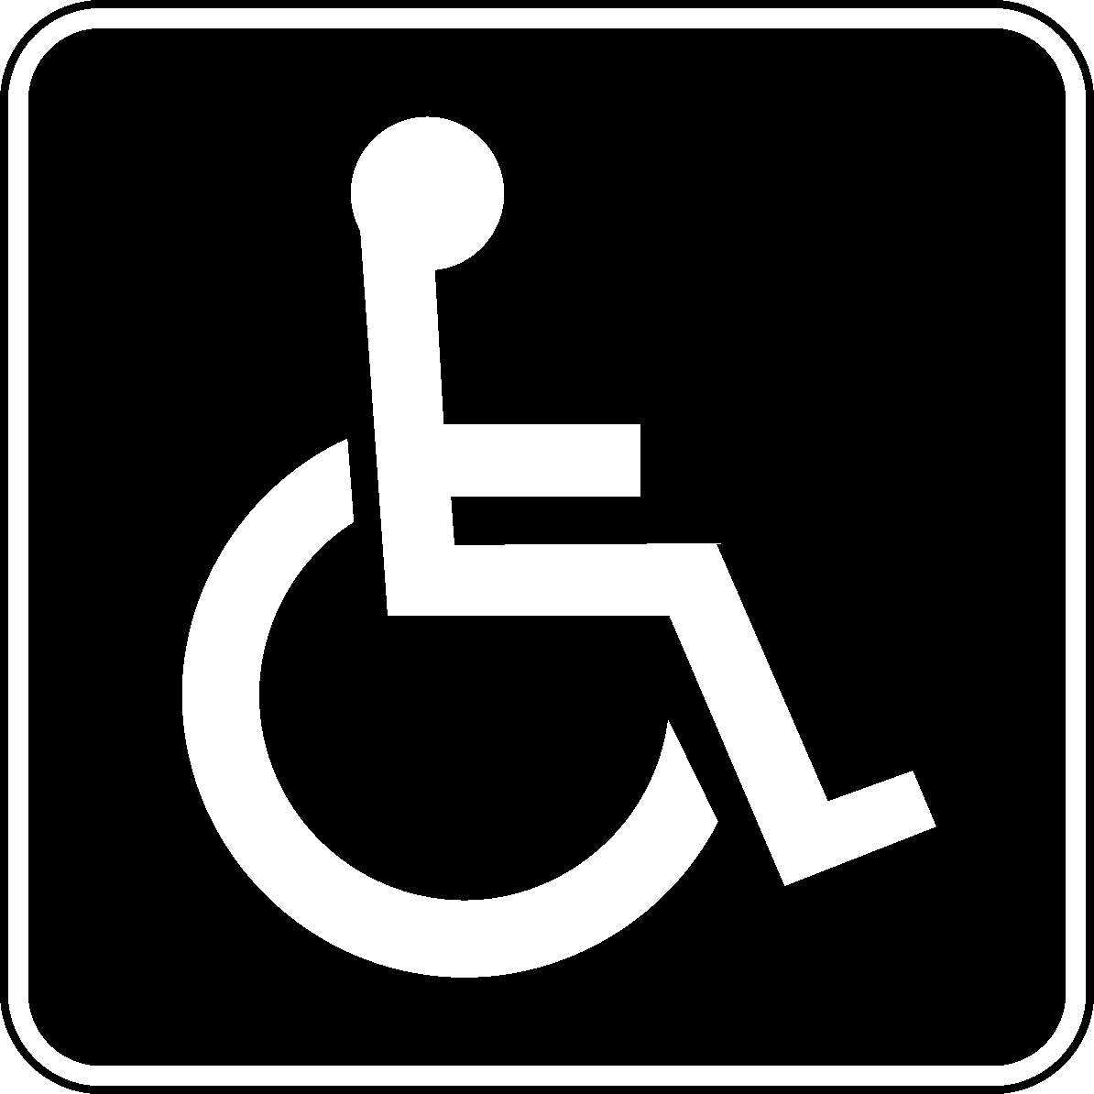
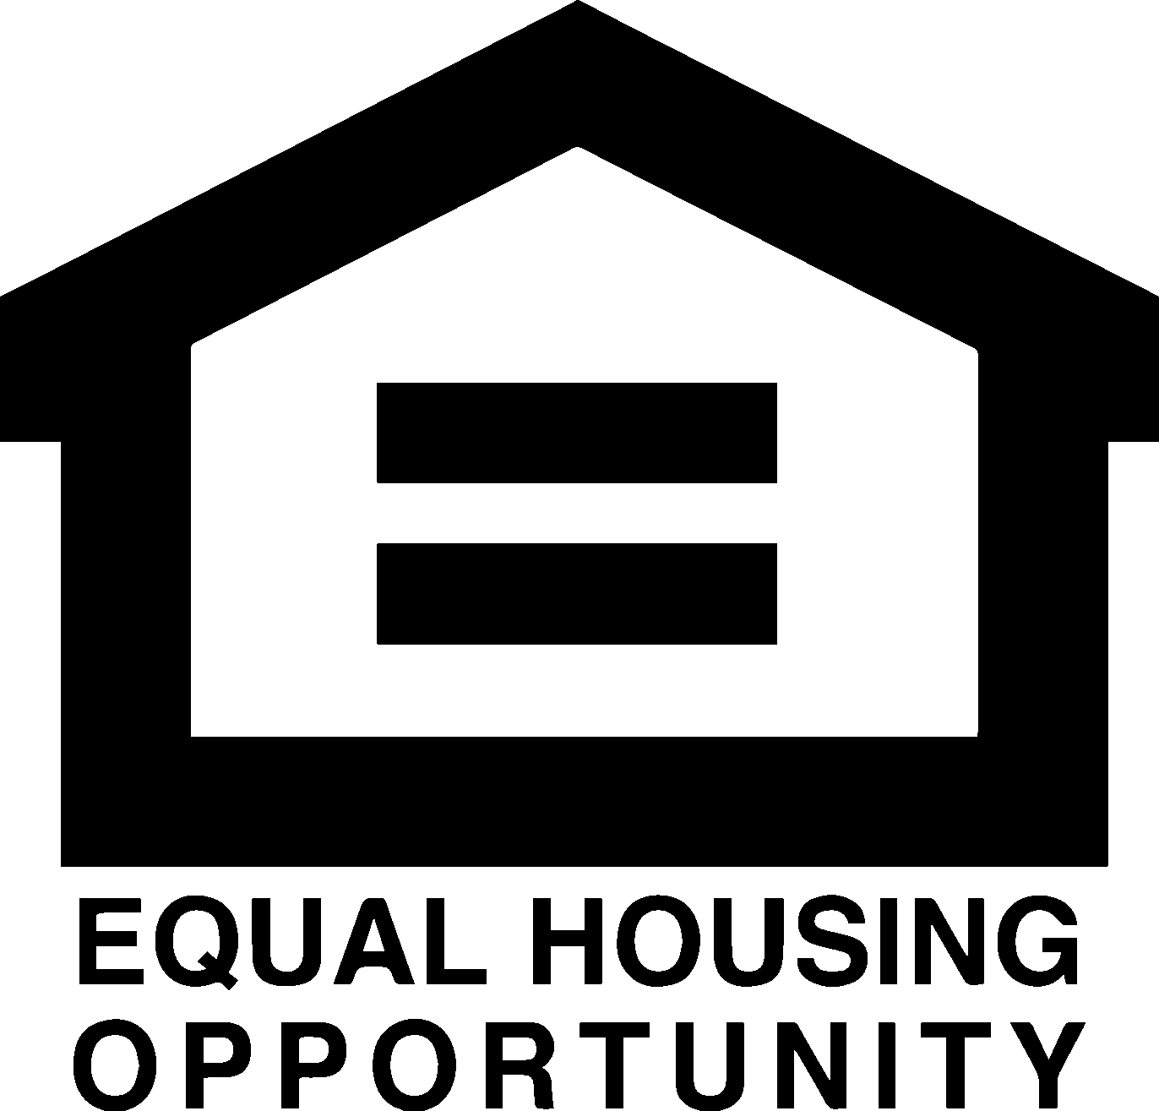
Disclaimer: Submission of a pre-application does not guarantee placement on the waiting list

